EXPERIMENT – 09 CREATE A SNAPSHOT OF A VM AND TEST IT BY LOADING THE PREVIOUS VERSION/CLONED VM USING VIRTUAL BOX.
Aim:
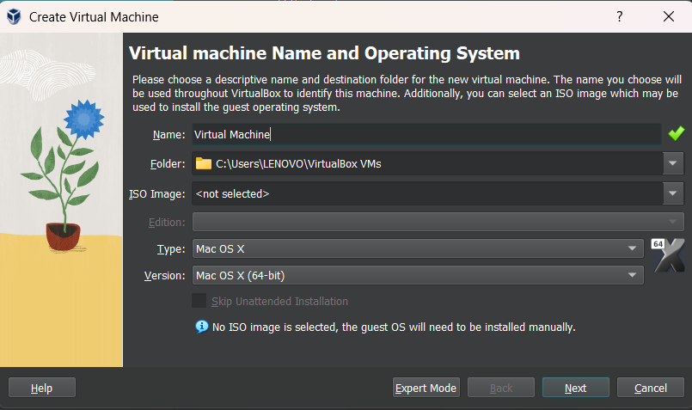
To create a snapshot of a Virtual Machine in VirtualBox and test it by restoring to the previous version or cloned state.

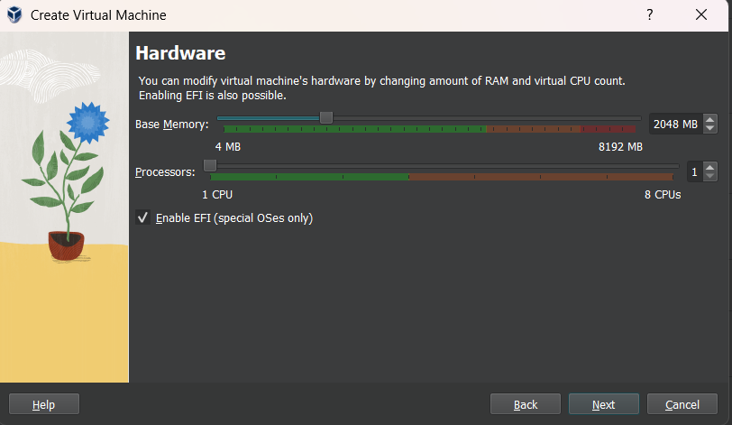

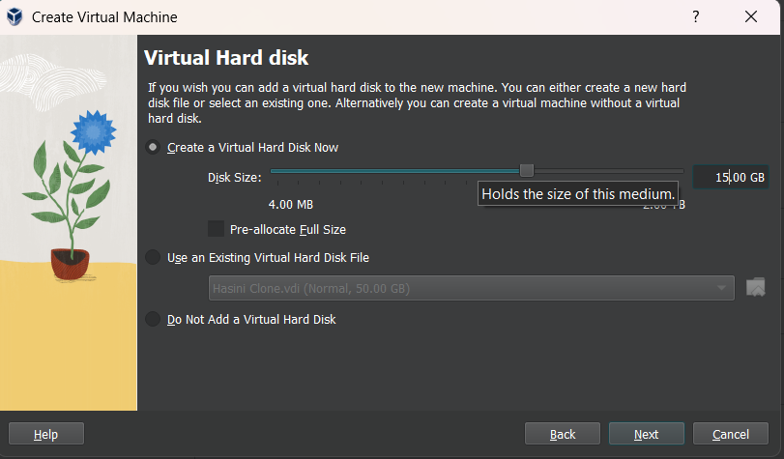

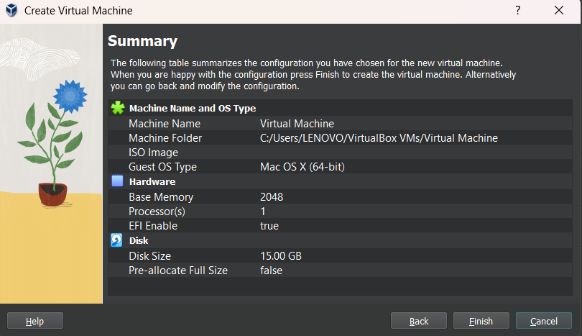
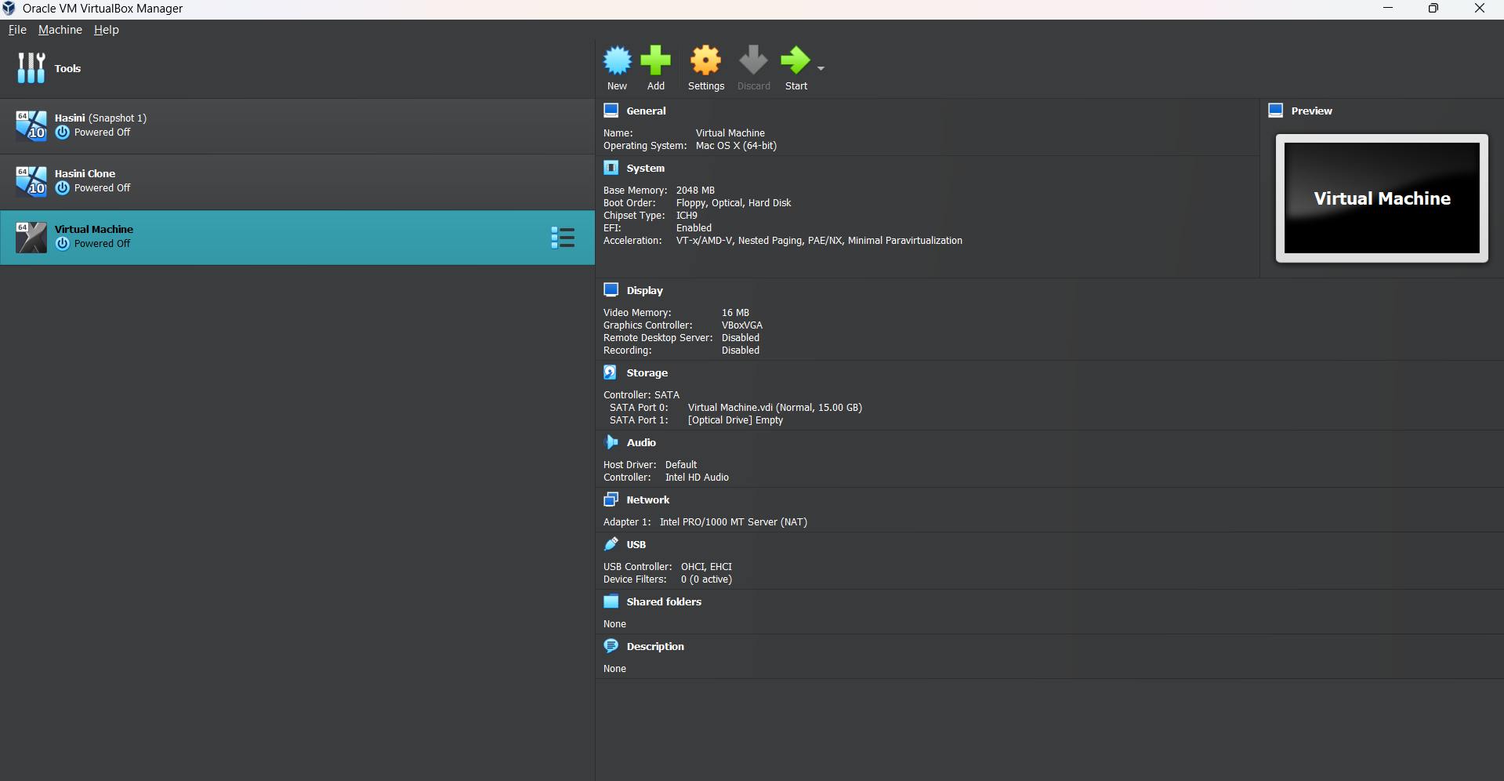

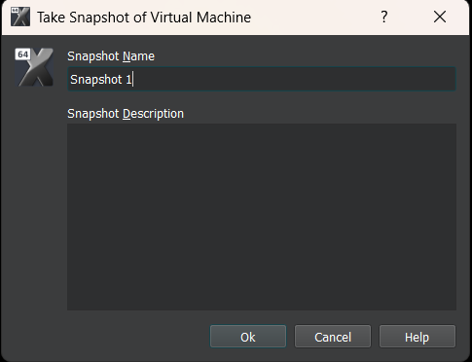

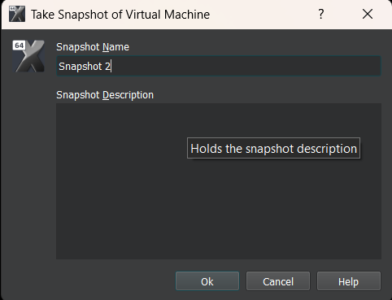
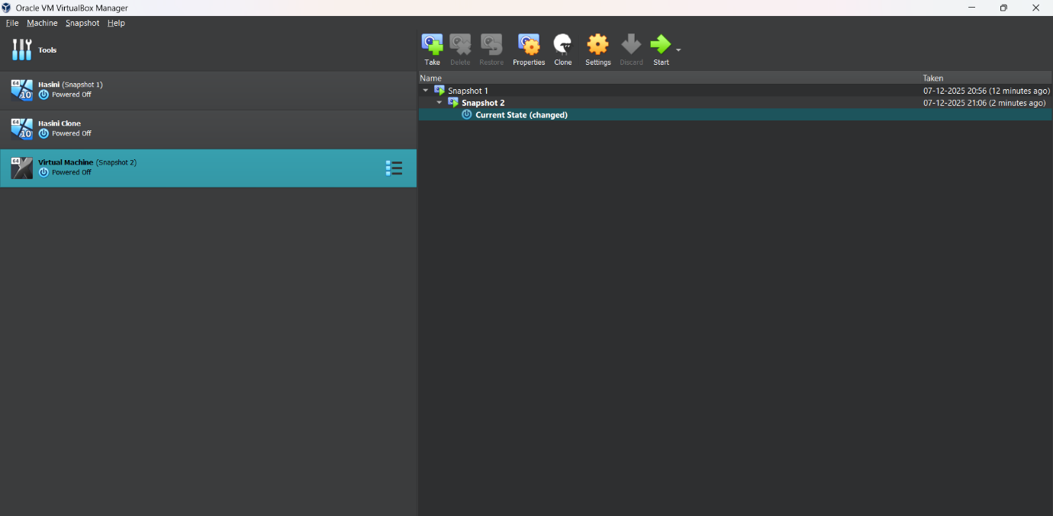

Result:
A snapshot of the VM was successfully created in VirtualBox. Restoring the snapshot reverted the VM to its previous state, demonstrating the functionality of snapshots for backup and testing purposes.

